Is this report confidential? | No
Report of | Meeting | Date
Director of Finance and Section 151 Officer  (Introduced by Cabinet Member (Finance, Property and Assets)) | Council | 23 February 2022
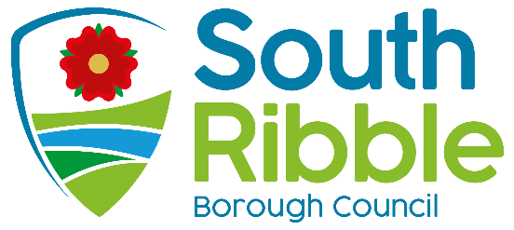
Is this decision key? | Yes

Savings or expenditure amounting to greater than £100,000 | Significant impact on 2 or more council wards
Revenue Budget 2022/23, Medium Term Financial Strategy and Capital Programme 2022-2025

Purpose of the Report
- To seek approval of the Budget Strategy and proposals for the Revenue Budget 2022/23, together with the Medium Term Financial Strategy (MTFS) and Capital Programme for 2022-2025brief overview of what you are asking members to consider

Recommendations to Council (delete if not applicable)
- The Cabinet recommends that Council:

- Approve the budget and proposals set out in this report, including the level of Council Tax as set out in the Formal Council Tax Resolution, including Parish Precepts, for 2022/23, at Appendix A;

- Note the advice of the Chief Finance Officer in relation to the robustness of the estimates within the overall budget, including the risks contained within it and the adequacy of the proposed level of financial reserves, as set out in the Statutory Report at Appendices B1 – B3;

- Approve the council’s Medium-Term Financial Strategy (MTFS) at Appendix C;

- Note the council’s forecast Cumulative Budget Deficit and Budget Strategy 2021-22 to 2024-25 at Appendix D;

- Note the analysis of the movement in the 2022/23 Budget from the position approved by Council in February 2021 at Appendix E;

- Approve the capital programme for 2021/22 to 2024/25 (Appendices F1, F2 & F3);

- Approve the Capital Strategy at Appendix G;

- Approve the Treasury Management Strategy at Appendix H and note the advice of the treasury management consultants at Appendix H1;

- Approve the council’s Pay Policy at Appendix I for publication on the council’s website from April 2022;

- Note the budget consultation 2022/23 Report at Appendix J;

- Note the Assessing the Impact of Budget Proposals 2022/23 Report at Appendix K.

Reasons for recommendations
- To ensure the Council complies with the statutory requirement to set a balanced budget for 2022/23.

Other options considered and rejected
- None; setting the budget is a statutory requirement.

Executive summary
- This 2022/23 budget and the MTFS for the next 3 years have been updated to take account of the following:
  - a freeze on council tax in 2022/23.
  - a freeze on council tax in 2023/24 and a 1.99% increase in council tax in 2024/25, although these proposals will be revisited each year as part of the budget setting process and will be dependent upon the outcome of the government’s reviews of both the future funding framework and the future distribution of funding between councils;
  - continued investment in ongoing revenue budgets to ensure delivery of corporate strategy priorities of over £1million;
  - capital investments of over £71.6m are included in respect of corporate priority projects;
  - the figures incorporate strategies to reduce the budget deficit over the medium term

- The report presents a balanced budget for 2022/23 and, based on current assumptions detailed within the report, forecasts deficits of £0.619m for 2023/24 and £0.732m for 2024/25, however, the council is ambitious in its approach to meeting the budget deficit through generating efficiency savings, such as those already realised through shared services, and additional income generated through investments within the borough.

- The council is expanding its capital programme with large scale investments included in the budget over the coming three years.

- The budget is set to ensure the objectives of the council’s Corporate Strategy priorities are met;

- An exemplary council – we will continue to work with our residents to address climate change and achieve our commitment of being a carbon neutral council by 2030
- Thriving communities – providing support and grants for businesses and developing our approach to apprenticeships, graduate and training posts in areas of high market demand and supporting people into high quality employment;
- A fair local economy that works for everyone – investing in our local play and community facilities, supporting the delivery of affordable homes and improving our leisure centres;

- Good homes, green spaces, healthy places - making improvements across the Borough, supporting our young people, health and wellbeing and local areas is only necessary for reports of longer than 4 sides and should include detail on HR and customer service implications of the decision.

Corporate priorities
- The report relates to the following corporate priorities: (please bold all those applicable):

An exemplary council | Thriving communities
A fair local economy that works for everyone | Good homes, green spaces, healthy places

Background to the report
- A Cabinet considered their 2022/23 Draft Budget and Summary Budget Position over the Medium Term’ for recommendation to Full Council at their meeting on 9 February 2022.The report set out the Cabinet’s intention for spending and investment in the borough over the course of the 2022/23 financial year.

- At that time however the government had just published the Final Local Government Settlement which included a change to the figures and information published in the Provisional Local Government Settlement published on 16 December 2021. This has impacted on all councils and relates to additional S31 grant to be paid to compensate councils following restrictions on the uplift in Business Rate charges in 22/23. The additional funding relates to the indexation of this ‘lost increase’; as a result the council will receive an additional £300k of funding.

- In addition, and again related to Business Rates, the council submitted its NNDR1 Business Rates return on 31st January to government. An increase in the Business Rates base has given rise to an additional £300k over and above that included within the 2022/23 Draft Budget report considered by Cabinet.

- As a consequence of the above increases, the Cabinet has re-considered the recommendations they were intending to make to Full Council, and also taking into consideration the feedback from the results of the Budget Consultation, and they are now recommending that the additional funding is used to;
- Freeze Council Tax in 2022/23
- Increase investment in the Boost Funds and in our sports and community organisations
- Increase the Covid Recovery reserve to support the council, communities, residents and businesses in the recovery from the pandemic.

- These papers expand upon that report and set out in more detail for Council the Cabinet’s budget proposals in 2022/23short summary of the issues that have led to this report; any previous decisions or history which are relevant and help members understand the issues.

Climate change and air quality
- The report outlines the council’s commitment to climate change and references the successful bid of £5m secured for decarbonisation of the council’s buildings

Equality and diversity
- Consultation has been undertaken regarding this budget with the Integrated Impact Assessment reported at Appendix K to this report.

Risk

There are no immediate risks associated with this report however not approving the final budget report risks the council being unable to finance its future commitments to its corporate priorities

Comments of the Statutory Finance Officer
- The financial implications of the 2022/23 Budget are all contained within the report above but to clarify, all proposals are funded and can be accommodated; it should be noted however that the report does contain several assumptions on some future budget elements and on the final out-turn position for 2021/22. Should any of the assumptions or figures change due to unforeseen circumstances arising before 31st March 2022, the financial position will be reviewed and reported.

- The financial implications for the council over the three year period 2022/23 to 2024/25 are detailed in;
- Medium Term Financial Strategy 2022/23 to 2024/25 at Appendix C;
- Chief Finance Officer’s Report - robustness of the 2022/23 budget and the adequacy of financial reserves at Appendix B
- the risks and opportunities regarding the council’s capital programme are outlined in the Capital Strategy at Appendix G.

Comments of the Monitoring Officer
- The budget proposals are in accordance with the requirements of legislation

Report Author: | Email: | Telephone: | Date:
Louise Mattinson (Director of Finance) | Louise.mattinson@southribble.gov.uk | 01257 515151 | 14 February 2022

BUDGET CONSULTATION RESULTS
- Consultation on the 2022/23 budget ran from the 1 February to the 10 February 2022 and was conducted through an online survey.

- The consultation was publicised through a structured digital campaign which included eight posts on Facebook which accrued 818 link clicks, 73,588 views, reached 65,018 accounts and had 5676 engagements (likes, comments or shares).

- There were 220 responses received via the online survey, with 109 participants providing qualitative feedback through one open-ended question. Response levels have increased, compared to last year’s budget consultation survey, in which we received 105 responses.

- Participants were asked to rank on a scale of one (‘low priority’) to five (‘high priority’) what should be prioritised when allocating funding; the results are presented in detail at Appendix J.

- Part 2 of the consultation asked whether the respondent agreed with a Council Tax increase in line with inflation. The results showed a marginal disagreement. Open responses reflected the results of this, with residents’ concerns primarily being the current economic climate and the impact of what an increase would have in this climate.

Response | %
Agree | 46.7%
Disagree | 53.2%

2022/23 BUDGET – FUNDING SOURCES

Spending Review 2021 and Final Local Government Finance Settlement
- Uncertainty continues regarding the council’s future funding streams, with the government announcing a further one-year financial settlement for 2022/23 rather than the expected multi-year settlement. The figures included in the 2022/23 Budget have been made based on the Final Local Government Finance Settlement that was published on 7 February 2022.

Business Rates
- The 2022/23 budget assumes that the Lancashire Business Rates Pool will continue and the council will remain a member; South Ribble Council benefits from additional business rates income of approximately £1.396m as a result of being in the pool. In the absence of any further information regarding Business Rates Retention reform, the pool is assumed to continue throughout the period of the MTFS.

- Forecasting the level of business rates income beyond 2022/23 remains complicated due to the level of uncertainty in this area. Following various government announcements, councils have been expecting reforms to the business rates system for over four years. In March 2020, the government published the Terms of Reference for the Business Rates Review, setting out that the objectives of this were to reduce the overall burden on business, to improve the current business rates system and to consider more fundamental changes in the medium-to-long term. In March 2021, the government published the Interim Report of the review, with the final report issued in October 2021.

- The government has concluded from their review;
- that business rates are a vital component of the business tax mix;
- that they wish to preserve the benefits of business rates but will make changes to make their operation fairer and more effective for businesses;
- that they are not proposing changing the nature of the tax, or the basis of valuation;
- moving forward, they have concluded that increasing the frequency of revaluations would represent a fundamental and meaningful improvement to the business rates system and would help to ensure greater distributional fairness; currently, revaluations are scheduled to take place every 5 years although in practice, and due in part to the pandemic, these have only taken place about every 6-7 years. As such government has announced a 3-yearly cycle for business rates revaluations, starting from the next revaluation in 2023.

- In light of the above, the quantum of business rates that will remain available to the council after the reset is uncertain.

- It is also likely however that the level of funding that councils retain from business rates will be reviewed across the country as part of the government’s ‘levelling up’ agenda. This is expected to flow from the outcome of the Fair Funding Review, however no date has been set for these reforms. As such, in the absence of any further information, the budget assumes the council will retain the current level of business rates enjoyed as part of the Lancashire Pool throughout the three year period of the MTFS.

Council Tax

- The Local Government Finance Settlement confirmed a council tax increase limit for district councils of up to 2% or £5 (whichever is the greater) on a Band D equivalent in 2022/23. No announcement has been made regarding future years, however it is assumed that the same principles will continue throughout the future three-year budget period.
- Following receipt of the Final Govt settlement, after careful consideration as noted in point 13 above, Cabinet has recommended a freeze on Council Tax in 2022/23.

New Homes Bonus

- Funding from New Home Bonus (NHB) is assumed to discontinue in 2023/24. The provisional settlement announced an allocation of £802k for 2022/23. No further allocation is assumed after 2022/23. The government consulted on the future of NHB between February and April 2021 and is due to consult on proposed reforms shortly, with a view to implementing reform in 2023/24. It is expected that a replacement to this funding stream will be announced, however nothing further is known as to how the scheme will operate and what additional levels of funding, if any, will be made available to the council. Once more, this creates a significant degree of uncertainty for the council.

- It should be noted that this funding in 2022/23 is forecast to be passed to the City Deal as per the original agreement.

Lower Tier Services Grant and Services Grant

- As referenced above, every year the Government calculates the council’s core spending power; this is a combination of the council’s council tax income, business rates income and new homes bonus grant allocation. The government has retained the Lower Tier Services Grant to compensate the council in 2022/23 for the reduction in funding identified through the core spending power calculation; first introduced in 2021/22, this is a non-recurring, un-rinfenced grant of £107k.

- In 2022/23 the Government has also provided an additional Services Grant, again non-recurring and non-ringfenced, and distributed on the same basis as the Lower Tier Services Grant; the council’s allocation for this is £162k.

- Whilst a benefit to the 2022/23 budget, the one-off nature of this funding stream does mean that the council continues to face significant financial uncertainty over the medium term.

Summary of Major Sources of Council Funding

- The chart below outlines the forecast level of funding across the next three years in comparison to previous allocations. As the government has only published a one-year settlement, it is assumed that the Lower Tier Services Grant, the Services Grant and the New Homes Bonus will not continue in 2023/24 and beyond.
- As the graph shows, the funding to South Ribble Council is forecast to have risen slightly £13.9m in 2016/17 to £14.9m by 2024/25.

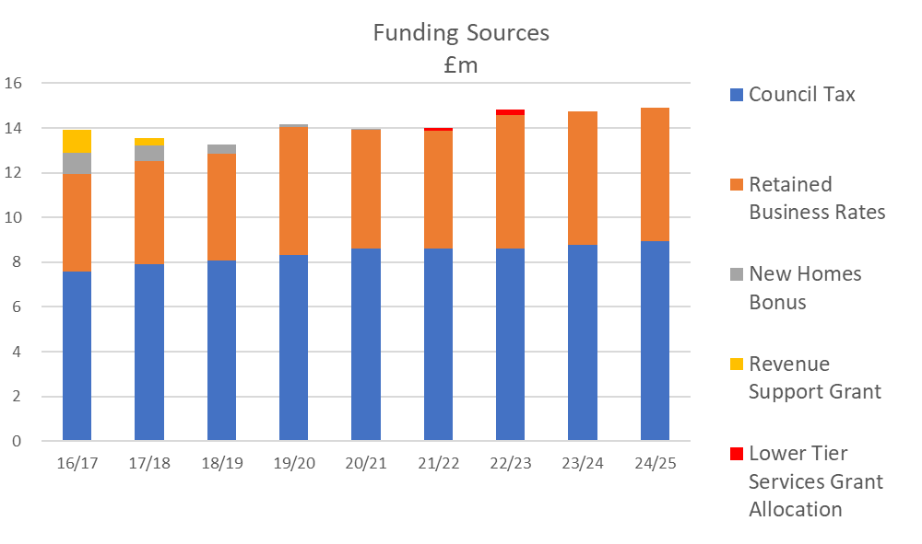

2022/23 BUDGET – EXPENDITURE

Salary Budget and Pay Award
- The 2020 Government spending review announced a pay freeze for 2021/22 for the majority of public sector staff, with a guaranteed a pay rise of at least £250 for all staff that earn less than £24,000 per year. At the time of writing this report, the pay negotiations are still ongoing for 2021/22, with the current offer of 1.75% made by the Employers having been rejected by the Trade Unions. The budget has however been adjusted to reflect an uplift of 1.75% in line with the current offer.
- In the Spending Review in October 2021, the Chancellor said that pay awards for public sector workers in 2022/23 would be in line with Consumer Price Index (CPI). With the negotiations for 2021/22 yet to conclude, and no fixed point in time announced for the determination of CPI, a provision of 2% has been made in the pay budget, which equates to approximately £230k per year, for South Ribble Borough Council in 2022/23; the Government’s proposals are not yet agreed with public sector unions.
- The spending review also announced that the National Living Wage will rise from £8.91 to £9.50 an hour and will be extended to workers aged 23 and over from April 2022. This will not affect South Ribble Borough Council’s pay bands for 2022/23 as the council pays above this level already.

- The salary budget includes a 2.5% allowance to reflect the fact that there will always be turnover of staff during a year that will cause a certain level of underspending due to the time it takes to recruit replacements; this equates to approximately £263k.

Pensions
- As part of their triennial pension review in 2019, the Lancashire County Pension Fund announced an increase in employer pension contributions for the council from 14.9% to 17.1% for each of the three financial years 2020/21 to 2022/23, to meet the future costs of the scheme. The same contribution rate is assumed for 2023/24 and 2024/25, although this will be reviewed when the new three-year review is undertaken.

Brexit and Covid 19
- Concerns remain about the impact of the United Kingdom’s withdrawal from the European Union (BREXIT). Much speculation continues around the likely financial effects of the leave arrangements, with potential risks to the council including increases in inflation and a slowdown in the local economy, impacting upon rental and property values and on income collected from business rates and council tax. In 2021/22 we have seen costs rise, for example:
- those driven by a shortage of HGV drivers which may continue to impact on the waste contract;
- increases in the costs of building materials sourced from the continent impacting on the cost of our capital programme, and;
- increases in the cost of food, both due to the cost of imports and due to the shortage of workers in the agricultural sector within our own economy as European workers have returned home; these cost increases have impacted upon the finances of our residents.

- The financial impact of Covid-19 has been outlined in the quarterly budget monitoring reports approved by Cabinet throughout 2021/22. This includes:
  - Reductions in council tax and business rates collection rates;
  - Government grant funding received to support various initiatives, including support to businesses, providing additional homelessness and food support to residents and support for the test and trace systems;
  - Government support for the reduced level of income received from fees and charges for the first three months of 2021/22, including reduced levels of leisure services income;
  - Reductions in rents at the council’s commercial sites.
- As part of the budget setting process for 2022/23, and the two years beyond, the following assumptions have been made regarding Covid-19 and the economy as a whole:
Income
  - That the impact of Covid-19 on the income from fees and charges will not be permanent and that levels will return to those pre-Covid, including the council’s major sources of income such planning fees;
Expenditure
  - That any expenditure relating to the council’s compliance with current or future government Covid-19 requirements will be met through existing budgets or grants from Government. This may include future grants to businesses, support to the homelessness or support to residents such as additional council tax support;
  - That the council will continue to support its wholly owned leisure services company, which was established on 1 September 2021. Whilst the leisure market remains extremely challenging, it is expected that this cost to the council will cease over the medium-term as the company develops its services to fully cover its own costs. Officers, as part of the company’s board, will develop a business plan for Cabinet to approve on behalf of Full Council. This will set out the plan for the reduction of costs over the coming years. The forecast position reflected in this budget, is that the financial support from the Council to the Leisure company will reduce from £583k in 2022/23 to £357k in 2023/24; the will mean that by 2023/24 the support provided by the Council will be £110k less than that previously paid to the Serco/Leisure Trust partnership. Whilst ambitious, given the national closure of leisure centres during Covid 19 and the resulting falls in membership, it is felt that this is an achievable target and the company will work to get to a position in which it is financially self-sufficient.

BUDGET DEFICIT

- The Council’s total budget deficit is summarised in Table 1 below and is based upon the key elements of funding and expenditure described above, and the budget assumptions outlined below.

Table 1: Total Budget Deficit

 | 2022/23 | 2023/24 | 2024/25
 | £m | £m | £m
Council Tax | (8.599) | (8.599) | (8.599)
Retained Business Rates | (5.969) | (5.969) | (5.969)
Lower Tier Services Grant and Services Grant | (0.269) | (0.000) | (0.000)
New Homes Bonus | (0.802) | (0.000) | (0.000)
TOTAL FUNDING | (15.639) | (14.568) | (14.568)
TOTAL NET EXPENDITURE | 15.694 | 15.307 | 15.582
BUDGET DEFICIT/(SURPLUS) | 0.055 | 0.739 | 1.014

- All deficits and savings identified in the Table 1 and in the remainder of this report are cumulative. For example, the deficit of £0.739m in 2023/24 identified above is the result of a £0.055m deficit in 2022/23 and further budget pressures and reduced funding of £0.684m identified for 2023/24.

Table 2: Key Budget Assumptions

Key Assumptions |  | 2022/23 | 2023/24 | 2024/25
Growth in the council’s Council Tax base |  | 0.0% | 0.0% | 0.0%
Council Tax Increases |  | 0.00% | 0.00% | 1.99%
Increase in Retained Business Rates through Growth |  | 0.0% | 0.0% | 0.0%
Financial benefit of membership of the Lancashire Business Rate Pool |  | £1.396m | £1.396m | £1.396m
New Homes Bonus |  | £802k | £0k | £0k
Lower Tier Services Grant and Services Grant |  | £269k | £0k | £0k
Future Service Pension Rate |  | 17.1% | 17.1% | 17.1%
Pay Award |  | 2% | 2% | 2%

- A detailed breakdown of the three-year budget, including the gross budget deficit is provided in Appendix D, ‘Cumulative Budget Deficit and Budget Strategy 2021/22 to 2024/25’ of this agenda. Included in this appendix are the revenue budget implications regarding the Council’s capital projects.

- As with other assumptions it should be noted that the profile of expenditure and income is potentially subject to change.

- Risks surrounding these budget assumptions may be managed through the use of general reserves as outlined at the end of this report. A full description of budget assumptions and risks are provided in Appendix B1, ‘Report of the Chief Finance Officer - robustness of the 2022/23 budget and the adequacy of financial reserves’, and in the supporting Appendices B2 ‘Risks to the Medium Term Financial Strategy’ and B3, ‘Financial Reserves’.

BALANCING THE BUDGET IN 2022/23
- Funding to South Ribble Borough Council has remained relatively stable since 2016/17 in cash terms from a figure then of £13.909m, to a forecast figure of £14.568m in 2024/25. During the period to date, the council has continued to experience inflationary increases in staffing and non-staff costs, however, the council has been ambitious in its approach to meeting the budget deficit by realising efficiency savings and generating additional income.
- The council has been successful in controlling its costs whilst continuing to provide the high-quality services that are expected by its residents. The council achieves this by continually reviewing its budgets and contracts as well as exploring and investing in alternative delivery models; this has included sharing services with Chorley Council.
- The council will continue to invest in the borough to improve housing and to maximise opportunities to generate income, thereby making the council less reliant on the increasingly uncertain funding from Government.

Table 3: Balancing the Budget

 | 2022/23 | 2023/24 | 2024/25
 | £m | £m | £m
TOTAL BUDGET DEFICIT | 0.055 | 0.739 | 1.014
DFG Admin Charge to 12.5% | (0.055) | (0.055) | (0.055)
Net Income from Capital Investment (net of borrowing and running costs) | (0.000) | (0.065) | (0.065)
Council Tax Increase – Freeze in 22/23 and in 23/24 and 1.99% increase in 24/25 | (0.000) | (0.000) | (0.162)
NET DEFICIT / (SURPLUS) | 0.000 | 0.619 | 0.732

- The council receives approximately £700k per annum external grant funding to deliver its Disabled Facilities programme. This funding enables residents to adapt their homes so that they can continue to live independently. The council currently charges a 5% administration charge to the fund to part-fund South Ribble staffing costs of delivering the programme. A review of the service has indicated that this charge is not sufficient to meet the costs of delivery and so the administration charge will be brought into line with the actual costs of managing the scheme. This charge is in line with the administration charges of other neighbouring authorities. The additional income from this increased charge will also fund an additional post to support the scheme. The increase in the administration charge will not affect the council’s obligation to meet the demand for adaptations from its residents and is not an additional charge to residents.

INVESTING IN OUR PRIORITIES
- The council continues to invest in delivering the ambitions set out in its Corporate Strategy and to ensure that the council delivers high quality services to its residents. The key areas of investment are set out on the following pages.
Investing in corporate priorities
In 2021/22 the council allocated over £1m of revenue investment to deliver corporate strategy priorities through projects and initiatives. These ensured that the right conditions are created and provide the opportunities for everyone in South Ribble to succeed and thrive. In line with our four priorities these investments ensure a healthy and happy community, flourishing together in a safer and fairer borough that is led by a council recognised for being innovative, financially sustainable and accountable.

Thriving communities
£50k which has been provided to support positive mental health for young people. Mental Health First Aid training has been provided, Community Mental Health Awareness sessions have been delivered in Penwortham, Leyland and Bamber Bridge and work continues in the evolution of the South Ribble Together Network, made up of agencies who support the work of the South Ribble Together Hub.
£265k to refurbish Vernon Carus Sports Club, work started on site in January to refurbish the existing club house and changing rooms with completion planned for April ahead of the new Cricket season, this will which provide some of the best sporting facilities for our residents to encourage more and more people to access 'Leisure Local'.
A fair local economy that works for everyone
£150k which has created a Credit Union that will enable access to safe and ethical banking options for all residents, with nearly 100 new savers during the first two quarters of opening.
Investment of at least £33m to continue to fund the Town Deal, including £25m of external funding and £8m of match funding by the council, to invest in current and new buildings to create a 'new heart' for Leyland, including Leyland market improvements and a business hub development for business for workspace, events and skills.

Good homes, green spaces, healthy places
£2m to continue to deliver affordable housing units with the completion of Tom Hanson House has provided nine new affordable flats which enables residents from across the borough to have access to affordable, safe and environmentally friendly housing, and will meet the demand of stock which is vitally needed.
£625k was allocated to fund improvements to play areas and open spaces, in addition a budget of £2.8m has been budgeted to construct new state of the art football pitches that are already under construction and due to be finished in early 2022/23.

An exemplary council
£2.9m to continue to refurbish Worden Hall which will see the hall transformed into a flexible community use space with provisions for small events and wedding.
£20,000 to improve digital access for less advantaged school children by providing 150 tablet devices to 10 schools across South Ribble

Looking ahead – investment priorities for 2022/23
In 2022/23 we will see further investment in key programmes all of which aim to support our communities to thrive; to drive forward innovations that allow us to continue being an exemplary council; to develop a fair local economy that works for everyone across the borough; and to deliver good homes and greener spaces for residents.
- We will invest £1.565m to improve parks, play areas and open spaces, including improvements to Hurst Grange, Birch Avenue - Penwortham, Moss Side Village Green, Farington Lodges, Strawberry Valley Park - Bent Lane, Withy Grove and Gregson Lane, Ryden Avenue and Hutton in 2022/23 and Longton, New Longton and King George Vand Margaret Road in Penwortham in 2023/24. We will also invest £200k for improvements to smaller open space and play areas.
- We will invest £1.600m to improve our leisure centre facilities
- £3.100m to continue to support the development of affordable homes including 15 new affordable homes on the McKenzie Arms site in Bamber Bridge; this means residents from across the borough can have access to affordable, safe and environmentally friendly housing, and will meet the demand of stock which is vitally needed.
- To support the recovery of the local economy following the pandemic, we will invest £200k on business support, advice and grants for local businesses to get back on their feet.

- £30k to support communities and residents to organise events to celebrate the Queen’s Jubilee.

- £200k on targeting fly-tipping and environmental improvements across the borough to enable clean and safe local areas for residents.

- £250k to create a community support fund, working alongside our existing the Boost Fund and the community hubs to improve the lives of our residents and provide support for individuals, groups and organisations

- Our sports clubs and community organisations have been badly hit through loss of income and membership during pandemic. They provide the life-blood of the borough and so we will create a £250k fund for groups to continue and grow.

- To support people into high quality employment, build resilience and improve quality in our service provision as we recover from the pandemic we will invest £200k in creating more apprenticeships, graduates and training posts across the council in areas of high demand.
- Following our successful bid, we will utilise £5m in grant from government to decarbonise our assets; this grant will enable the council to significantly reduce its use of fossil fuels to power its leisure centres, vehicle depot and office buildings.

Medium Term Financial Planning and Transformation Strategy
- Despite the budget savings identified in this report, as outlined above at point xx, there remain forecast budget deficits of £0.619m in 2023/24 and £0.732m in 2024/25. The Council’s medium-term plans to reduce the budget deficits are outlined in Appendix D – ‘Delivering our priorities – Medium Term Financial Strategy 2022/23 to 2024/25’.

- The transformation strategy covers many aspects of change both within the council and in partnership with other organisations. The main strands of the strategy that could generate savings and income are outlined within Appendix D.

CAPITAL PROGRAMME 2021/22 to 2024/25
- Details of the capital programme, including new capital investment, are outlined in Appendix F1. The capital programme for 2021/22 to 2024/25 totals £71.6m and is an indication of how ambitious the Council is in delivering its Corporate Strategy and the priorities within it.

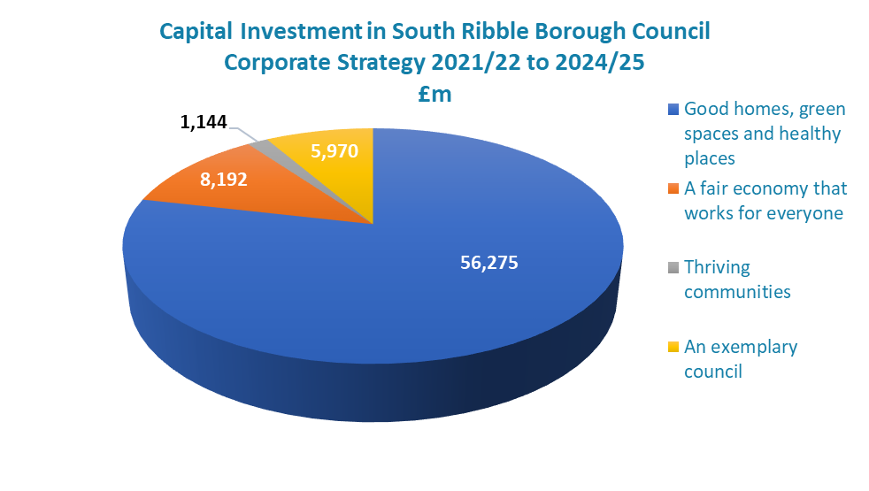

- South Ribble Council continues to invest through its capital programme to deliver on its ambitions.
This will include:
  - Improvements to play areas and open spaces across the borough
  - Delivery of affordable homes
  - Delivery of neighbourhood improvement projects for residents and communities right across the borough including xxx.
  - Improving the leisure centres and leisure and sports facilities to encourage our residents to be active and healthy.
  - Supporting our town centre through the delivery of the Towns Fund project
  - Supporting our ambition to become carbon neutral by 2030.

- The council’s capital programme is constructed based upon several objectives including the requirement to be affordable and prudent. To do this the council will ensure that whenever possible, the impact of additional investment on revenue budgets will be minimised.

- The council has a number of sources of funding it can use to invest in the borough including, Community Infrastructure Levy (CIL), section 106 funding, grant funding and capital receipts. Where appropriate the council will also generate future revenue income streams through capital investment to exceed the repayment of borrowing.

CAPITAL FINANCING
- The financing of the capital programme for the period 2022/23 to 2024/25 is set out in Appendix F2 to the budget report and summarised in the proceeding chart.

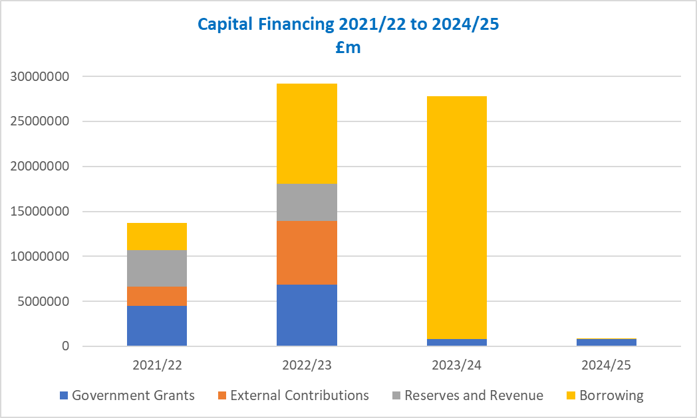

- The capital programme includes a number of schemes that are forecast to generate revenue that will meet the annual cost of borrowing required to complete the project. These include investment in affordable housing and extra care as well as future investments in sport and leisure services.

- The council will invest at least £5.4m over the coming three years of contributions from developers as outlined in Appendix F2. A summary of s106 funding received and allocated is attached in Appendix F3.

- Appendix G – Capital Strategy - to the budget report outlines the council’s capital strategy including specific risks within the programme, performance indicators and the council’s capital ambition beyond the three-year budget cycle.

CONCLUSIONS

- This paper outlines for the Council the Cabinet’s budget proposals for 2022/23 which are:

- A budget that sets out the risk to the council of the future uncertainty in Government funding over the medium-term.

- A budget that has allowed the council to commit to over £1m in revenue investment packages.

- Ensures investments can be made in key areas to support the Corporate Strategy:

  - An exemplary council
  - Thriving communities
  - A fair local economy that works for everyone
  - Good homes, green spaces, healthy places

- The assumptions included in the budget have been assessed in the light of the latest information available at this time. They are also compatible with:
  - the proposed Capital Strategy as set out in Appendix G
  - the proposed Treasury Management Strategy as set out in Appendix H
  - the proposed Pay Policy as set out in Appendix I.

- The MTFS contains the updated budget forecasts to 2023/24 which identifies that further budget savings will be required to bridge the funding gap in future years. The forecasted budget deficit in 2024/25 is estimated to be £0.732m and the MTFS sets out options that can be considered to bridge this gap. Therefore, the MTFS provides a plan to deliver a balanced budget over the longer term in Appendix C.

- The council will develop the Transformation Strategy to deliver efficiencies and additional income to support the continued provision of services to its residents and businesses. There are still factors that may affect the current forecast financial position namely the scheduled reform in business rates retention.

- The contents of this report are supplemented with additional reports, policies and statements to provide further details as referenced below:
Appendix A | Formal Council Tax Resolution 2022/23 including Special Expenses and Parish Precepts
Appendices B1 - B3 | Report of the Chief Finance Officer on the robustness of the estimates within the overall budget, including the risks contained within it and the adequacy of the proposed level of financial reserves
Appendix C | Delivering Our Priorities - Chorley Council Medium Term Financial Strategy 2022/23 to 2024/25
Appendix D | Cumulative Budget Deficit & Budget Strategy 2021-22 to 2024-25
Appendix E | Analysis of movement in the 2022/23 Budget from the position approved by Council in February 2021
Appendix F1 | Capital Programme 2021/22 to 2024/25
Appendix F2 | Capital Programme Financing 2021/22 to 2024/25
Appendix F3 | Developer's Contributions 2017/18 to 2024/25
Appendix G | Capital Strategy
Appendix H | Treasury Management Strategy 2022/23 to 2024/25
Appendix H1 | Advice of Treasury Management Consultants
Appendix I | Pay Policy 2022/23
Appendix J | Budget Consultation 2022/23
Appendix K | Assessing the Impact of 2022/23 Budget Proposals

